Types of Gateways
# Source: AI Source: Provided by: [Data Path: Persons Table -> ID Column: 1, Name_En Column: Motasem Essam] -> From: [ChatGPT] on [12/18/2025]
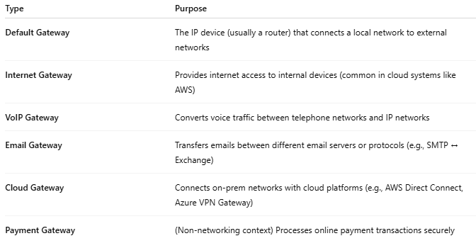
Type | Purpose
Default Gateway | The IP device (usually a router) that connects a local network to external networks
Internet Gateway | Provides internet access to internal devices (common in cloud systems like AWS)
VoIP Gateway | Converts voice traffic between telephone networks and IP networks
Email Gateway | Transfers emails between different email servers or protocols (e.g., SMTP ↔ Exchange)
Cloud Gateway | Connects on-prem networks with cloud platforms (e.g., AWS Direct Connect, Azure VPN Gateway)
Payment Gateway | (Non-networking context) Processes online payment transactions securely

